

**Sri Lanka Institute of Information Technology**

Faculty of Computing

Department of ISE

Group project undertaken in partial fulfillment of the requirements for the BSc

Degree in Cyber Security

Information Security Project – IE3092

Camouflage

IT18123296 – Shamry M.N.M

IT18133646 – De Silva M.W.D.S

**Introduction**

Our targeted audience for this practice drill is SEO analyst, military cyber experts, and for pentesters. And Our CTF project is based on Jeopardy-style CTF which we have use steganography technique with variety of categories in steganography in different types of challenges.

We have implemented six challenges, level 1, level 2, level 3, level 4, level 5 and level 6, respectively. We have develop the front end by using python and the backend has been developed using django framework to make sure our website is more secure by avoiding click jacking, cross site scripting and from sql injection.

**CTF Walkthrough**

**Level One**

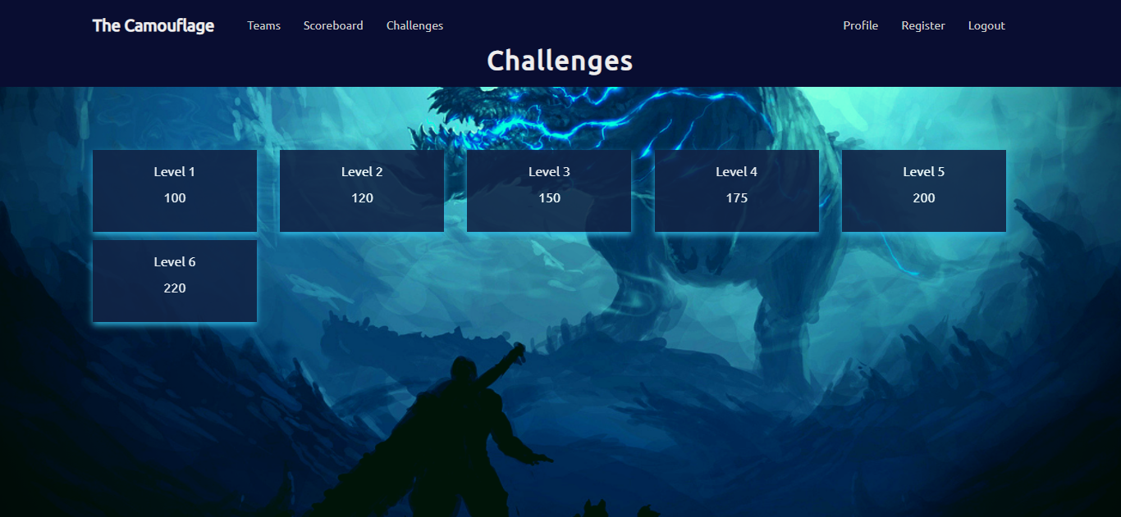

Figure 1.1

In this level you have to find out the flag which is hidden in an image.

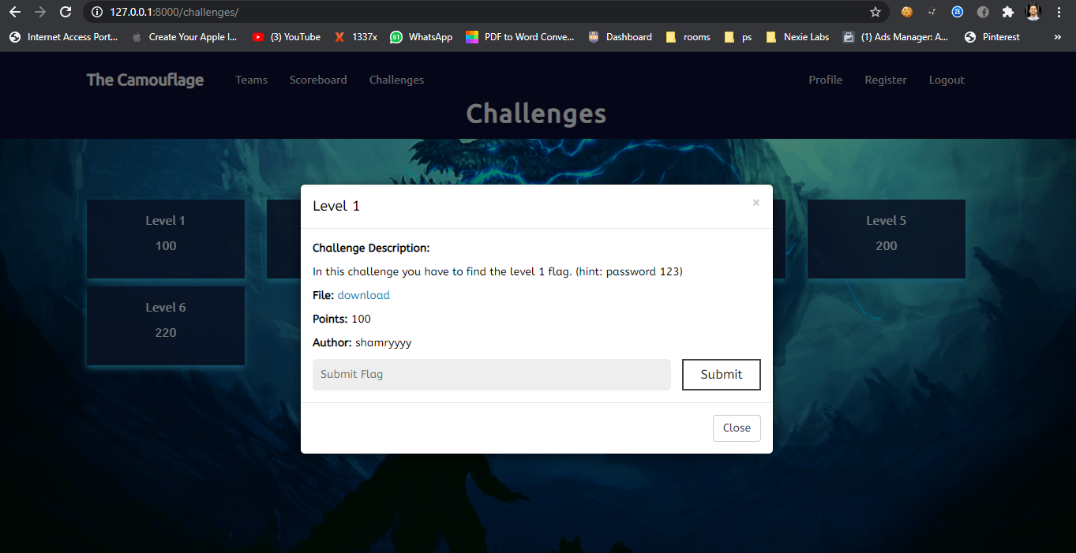Figure 1.2

First download the image file

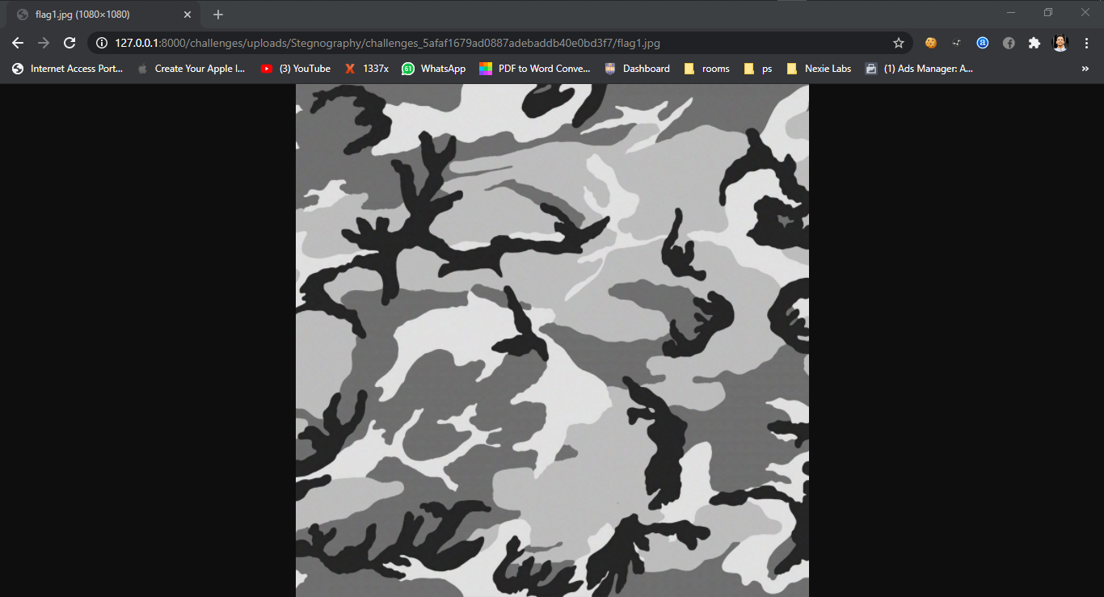

Figure 1.3

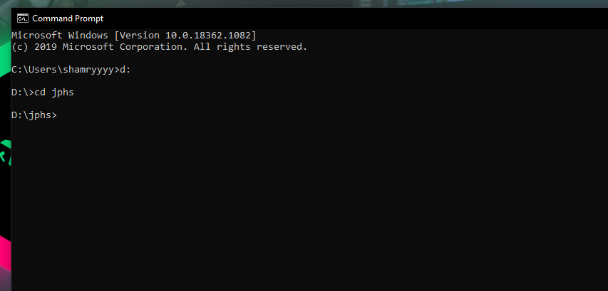

Figure 1.4

Typically attackers and lots of programmers use a tool called JPHS to hide and seek data in an image. I have used the same tool for hide the flag in an image.

JPHIDE and JPSEEK are programs which allow you to hide a file in a jpeg visual image. The design objective was not simply to hide a file but rather to do this in such a way that it is impossible to prove that the host file contains a hidden file.

By using JPHS tool, let's decode the flag.

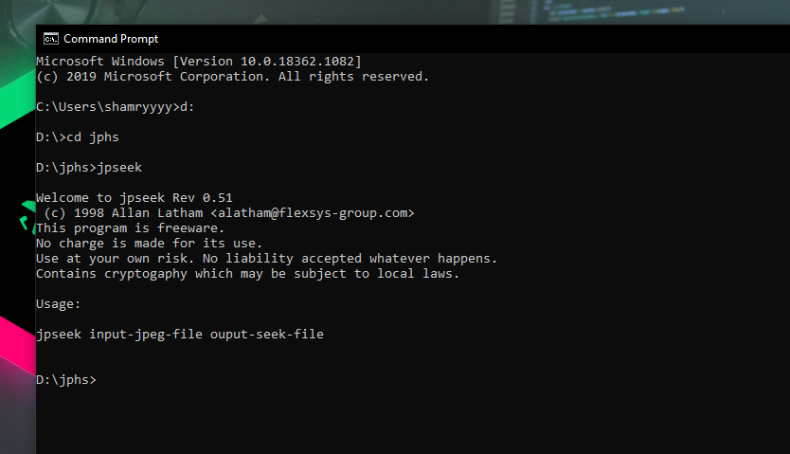

Figure 1.5

In here there are two main commands. 'jphide' is used to hide data in an image and 'jpseek' command is used to seek the data which is hidden in the image.

We are going to use 'jpseek' command here.

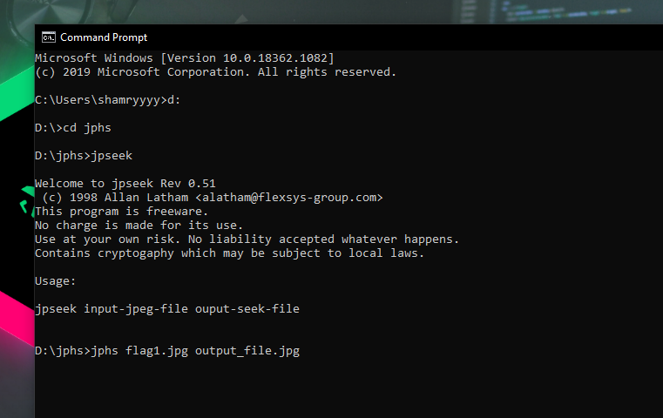

Figure 1.6

For that we have to type **‘ jpseek <downloaded image name.jpg> <we can give any name here.jpg> ’**

Then it'll seek the data and store with the name we have given as below.

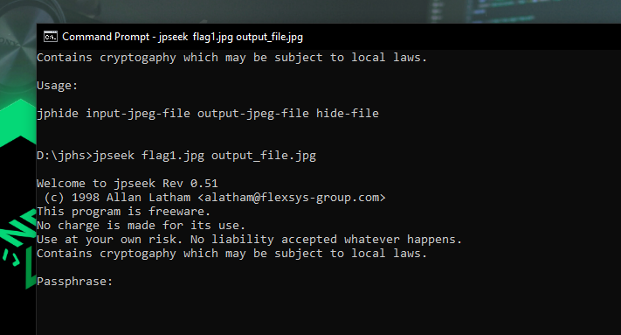

Figure 1.7

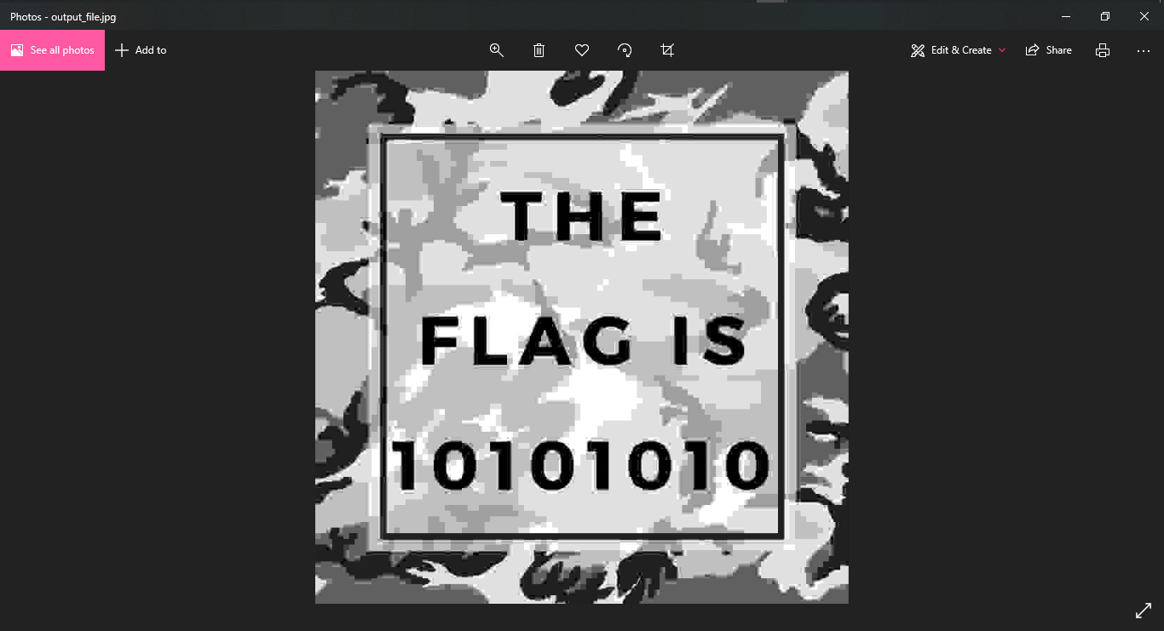Figure 1.8

The image which is extracted will contain the flag.

Then we have to submit flag in the website.

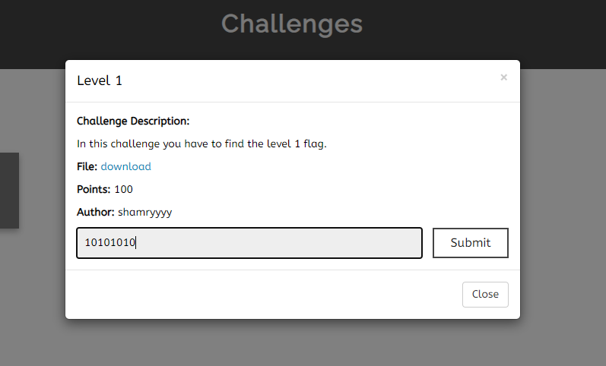

Figure 1.9

If the submitted flag is correct it'll prompt a message like this.

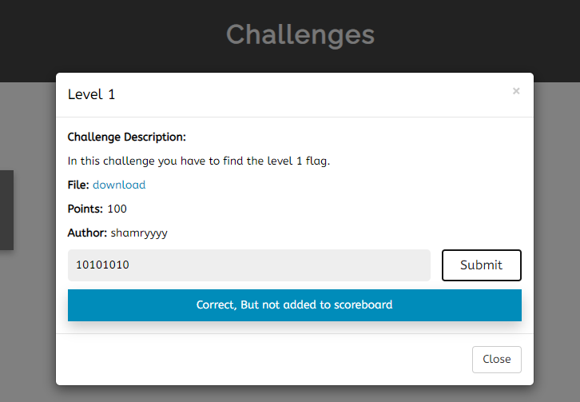

Figure 1.10

**Level Two**

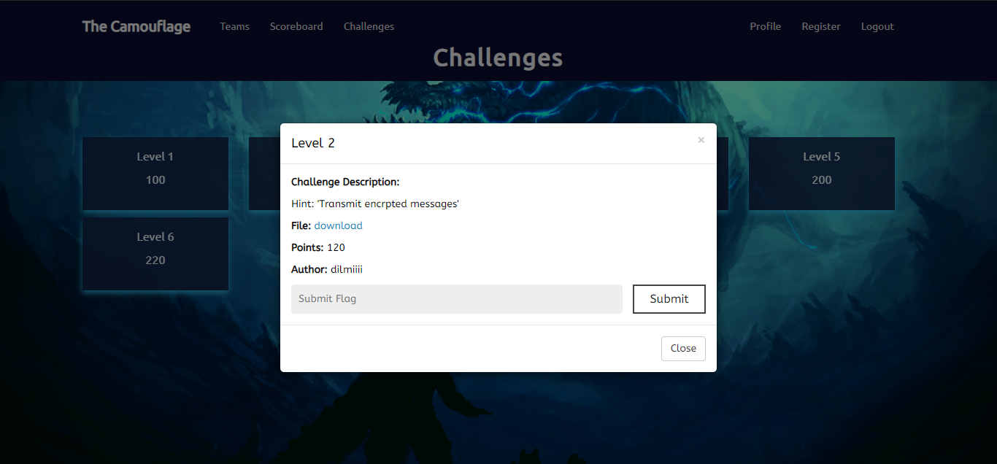In this level what we did is we hid the flag in a QR code but encrypted using moose code.

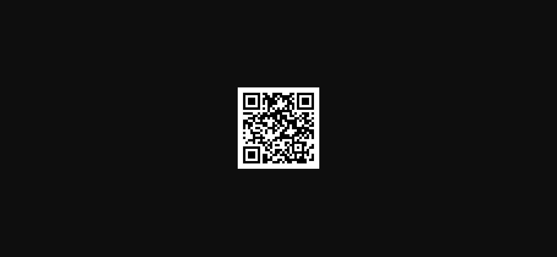Figure 2.1

First download the QR code.

Figure 2.2

Now scan it with a QR code scanner.

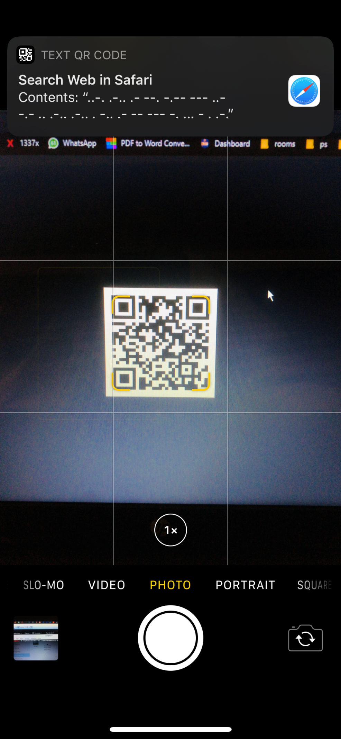

Figure 2.3

Then it will show the moose code.

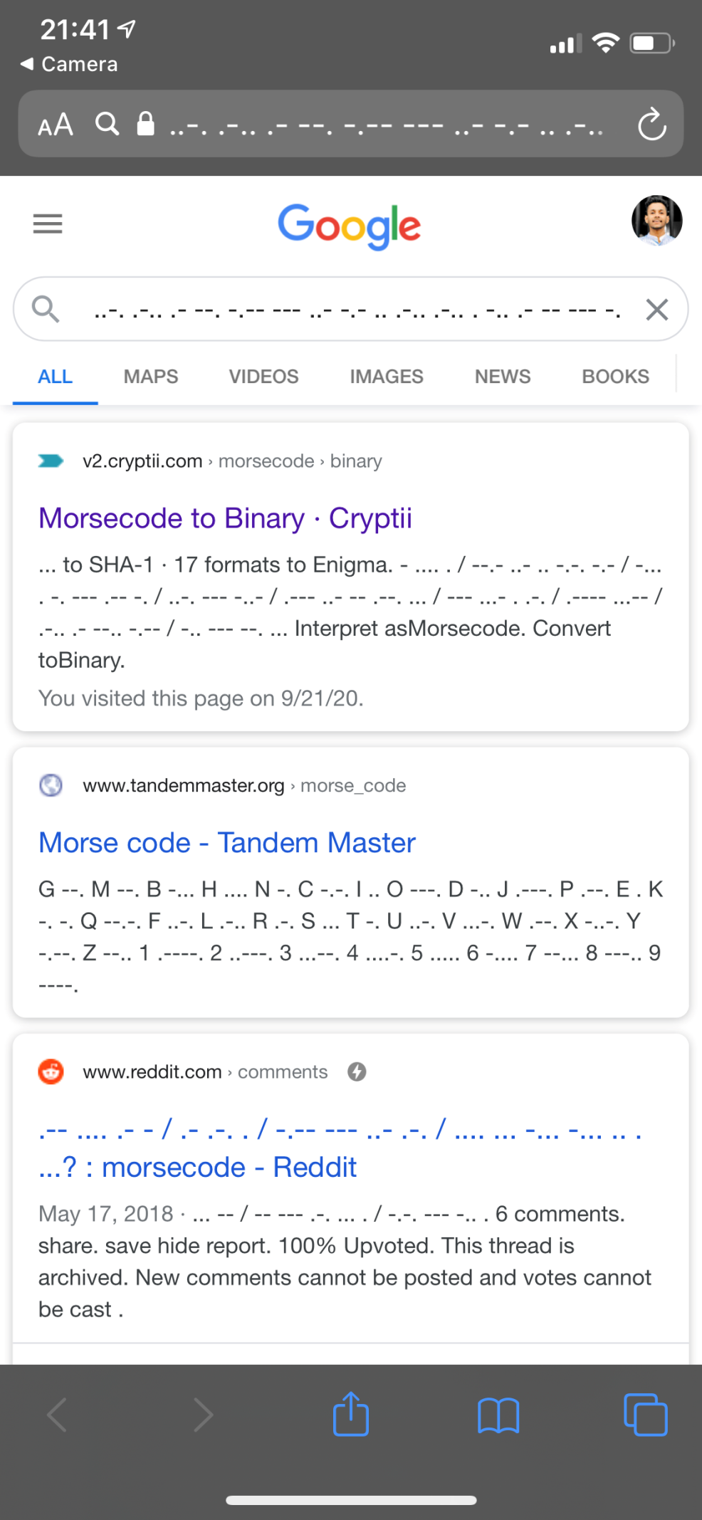

Figure 2.4

Then open a moose code decoder and decode above code. Then it will show you the fag

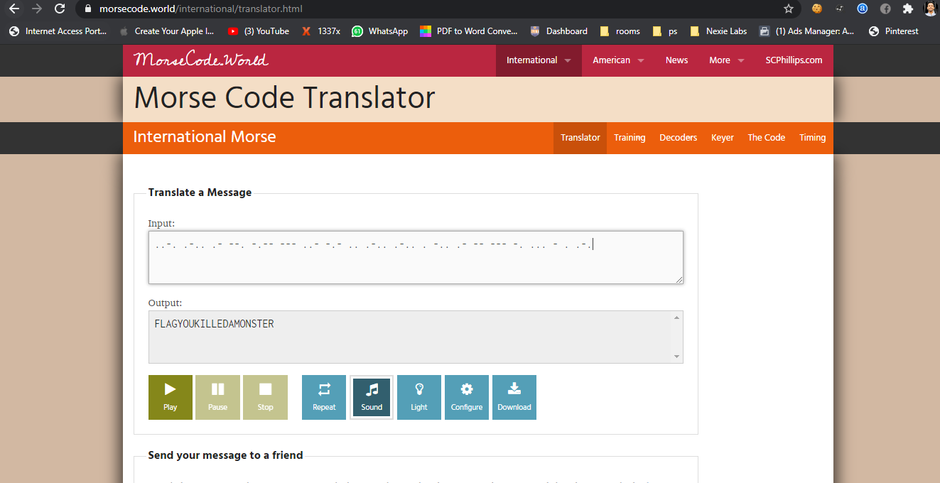Figure 2.5

Then submit the flag in the browser.

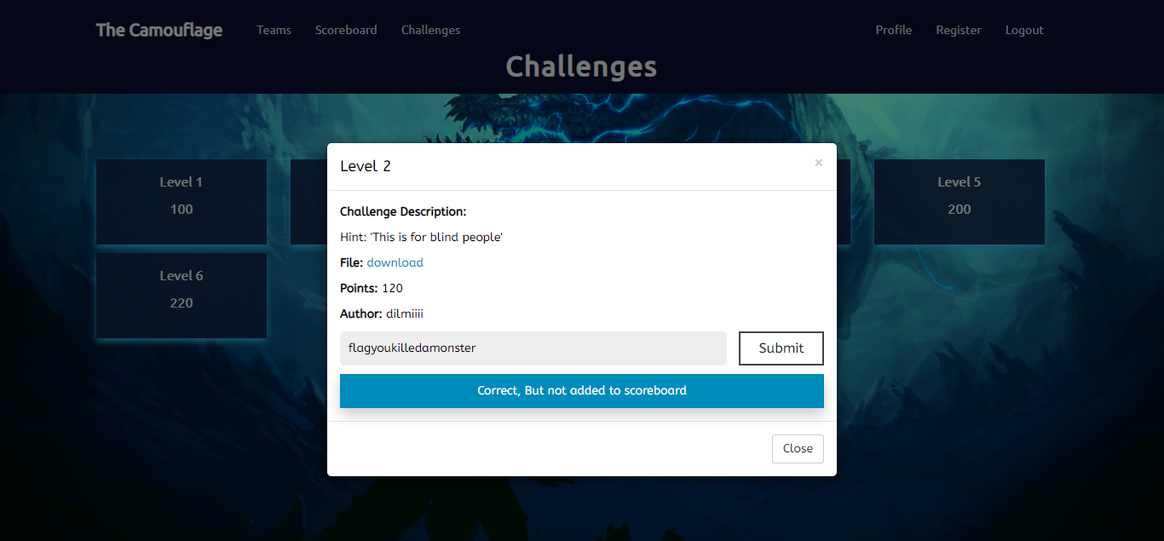Figure 2.6

**Level three**

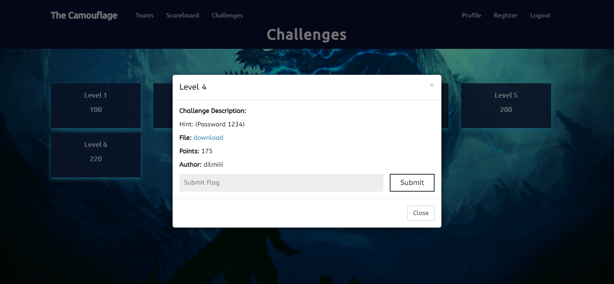

In this level we encrypted a secret file along with an image.

Figure 3.1

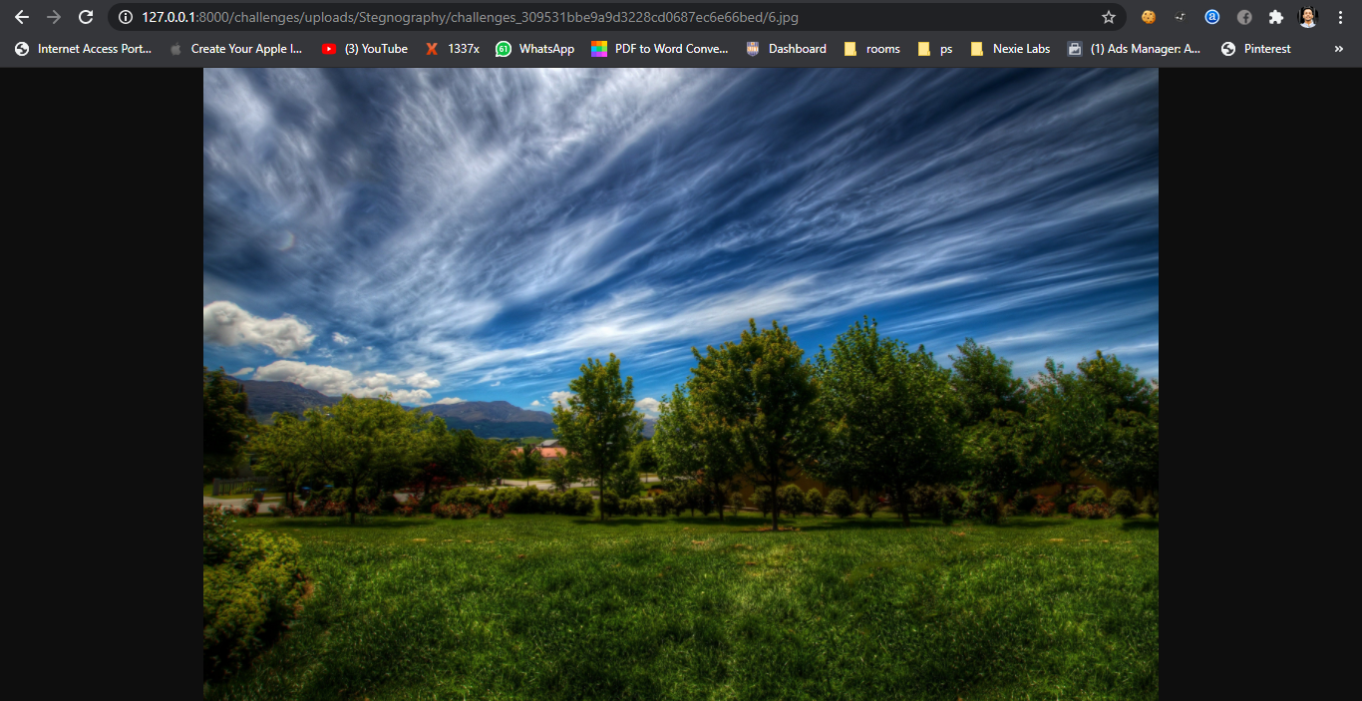Now let’s download the file.

Figure 3.2

To decrypt that we have to use a tool called **steghide** in kali Linux. After that use the below command to extract the file from the image.

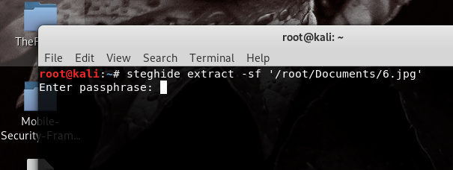

Figure 4.3

Then enter 1234 as the passphrase. Then you will get the secret file.

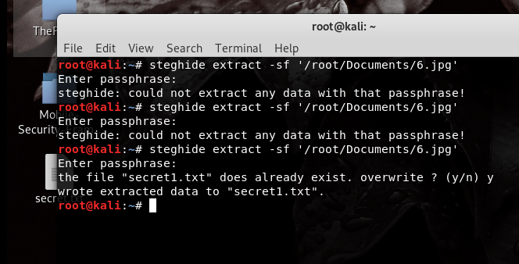

Figure 3.4

This is the secret file.

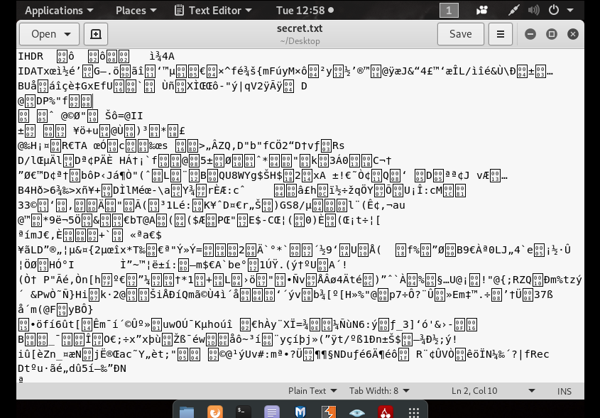

Figure 3.5

Then use ctrl + F to search the flag. You will a flag like below butt it is encrypted and we don’t know which language has been used to encrypt.

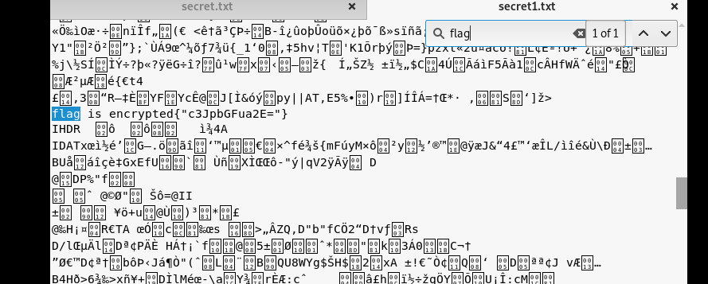

Figure 3.6

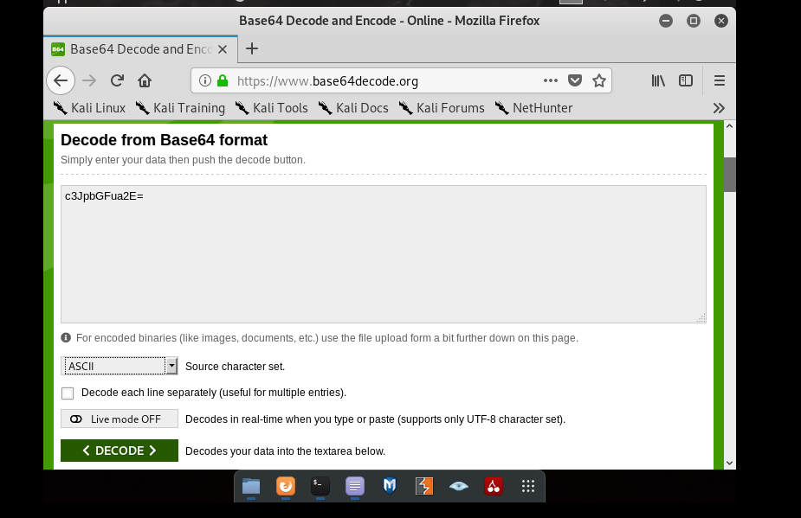To decrypt above value we are going to use base 64 ASCII decoder. Open base 64 ASCII decoder and decrypt above value.

Figure 3.7

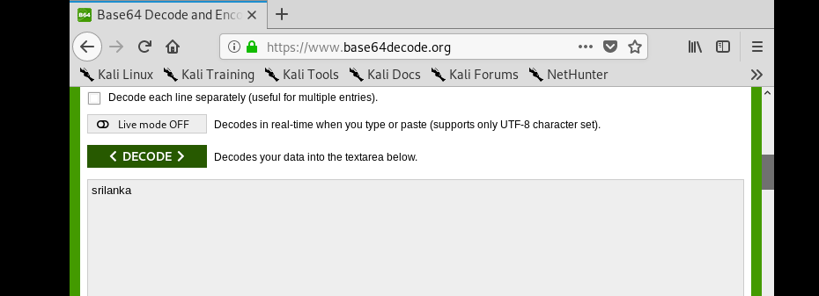

Then you will get the flag.

Figure 3.8

Then submit the flag for level four.

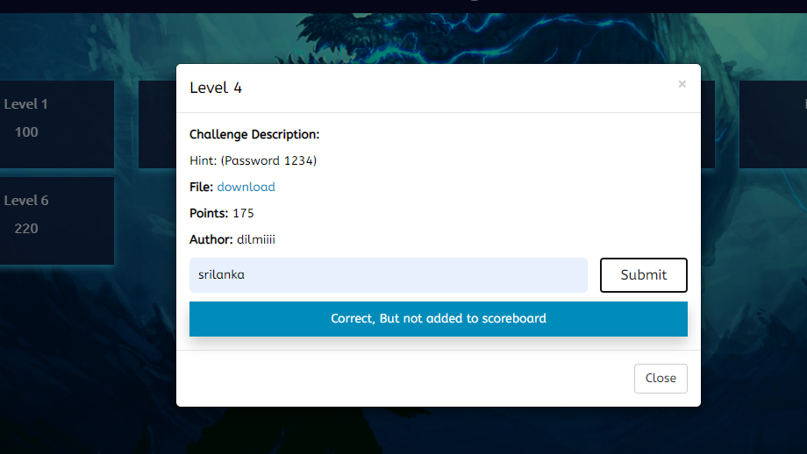

Figure 3.9

**Level four**

What we have done in level 4 is we hid the flag which is encrypted using braille code.

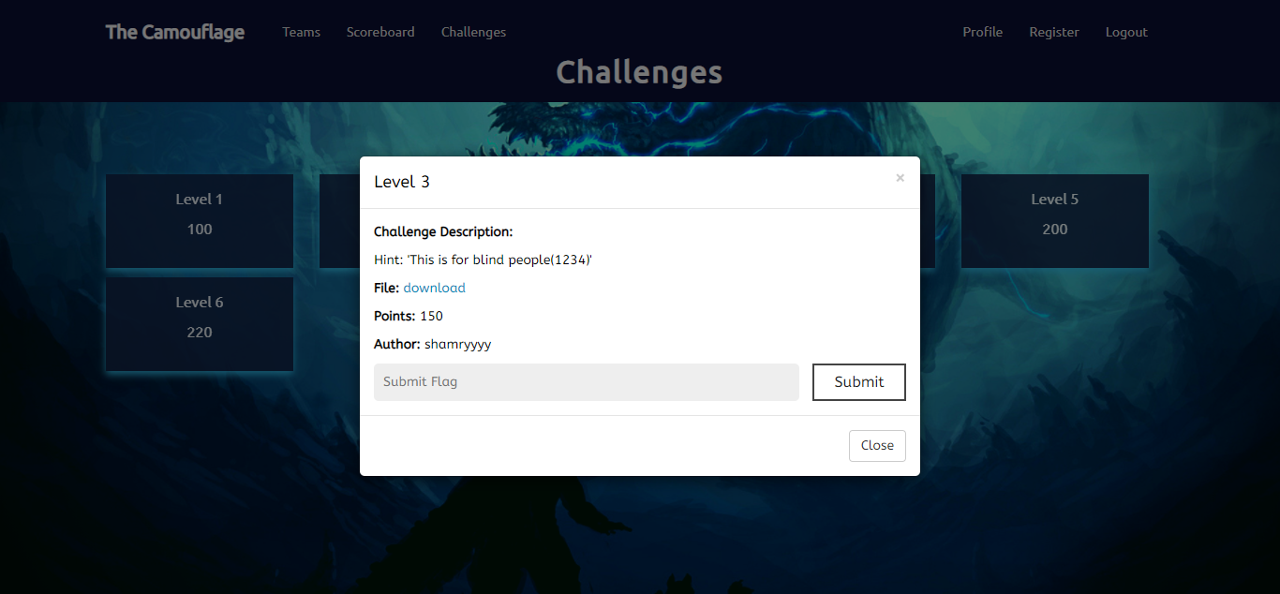Figure 4.1

This is the embedded picture.

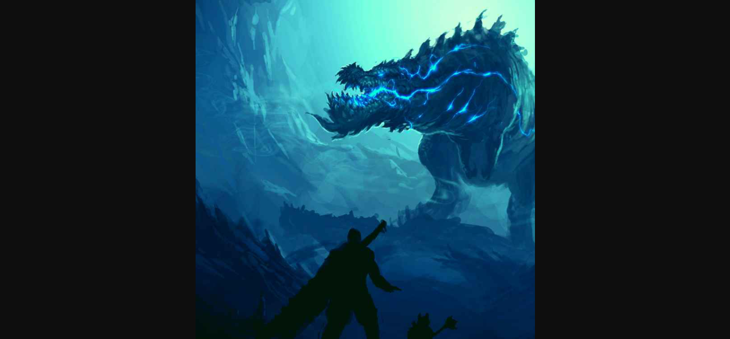Figure 4.2

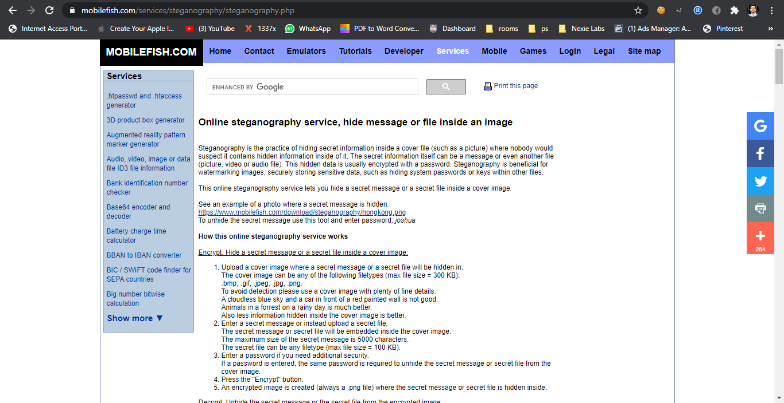There’s a website called mobilefish.com to extract hidden texts from embedded PNGs.

Figure 4.3

Upload the embedded image as shown below and enter the password as “1234”

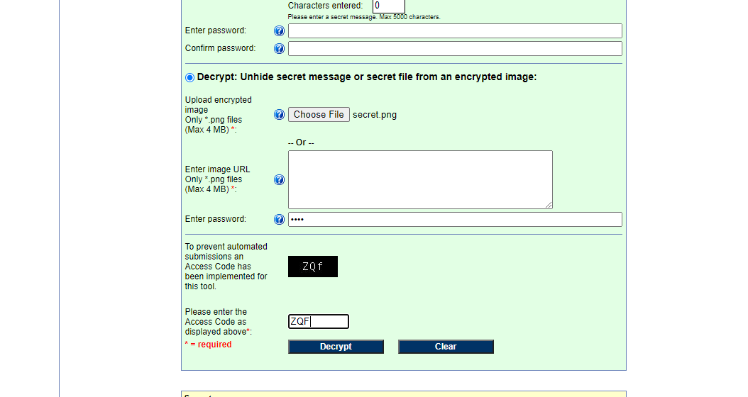

Figure 4.4

And then decrypt it. You will get a binary value, but this is not the flag.

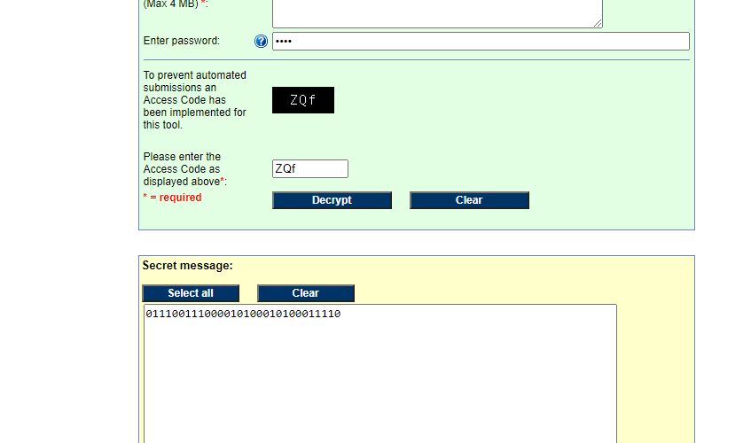

Figure 4.5

In the challenge description there is a hint saying this is only for blind people. So that means the above binary value should have been encrypted using braille language. Now open a braille decoder in the browser. After that paste the binary value and decode, you will get the flag.

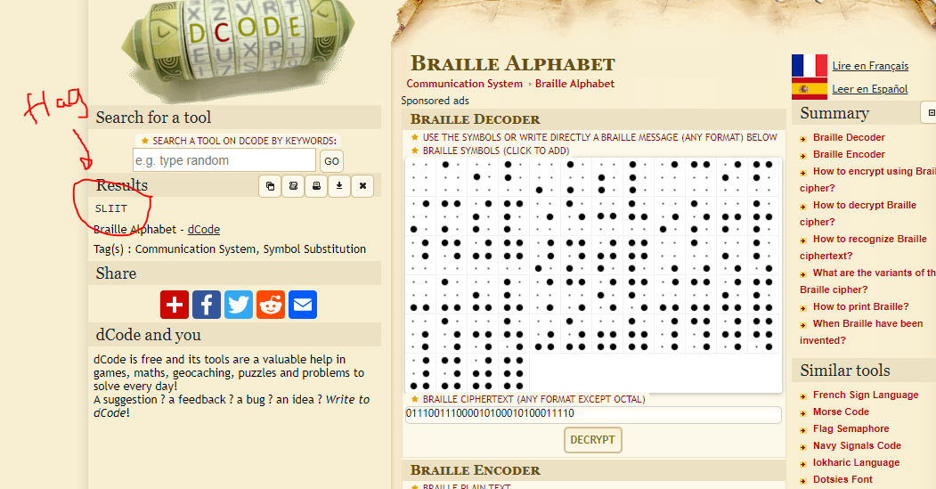Figure 4.6

And submit the flag in level 4.

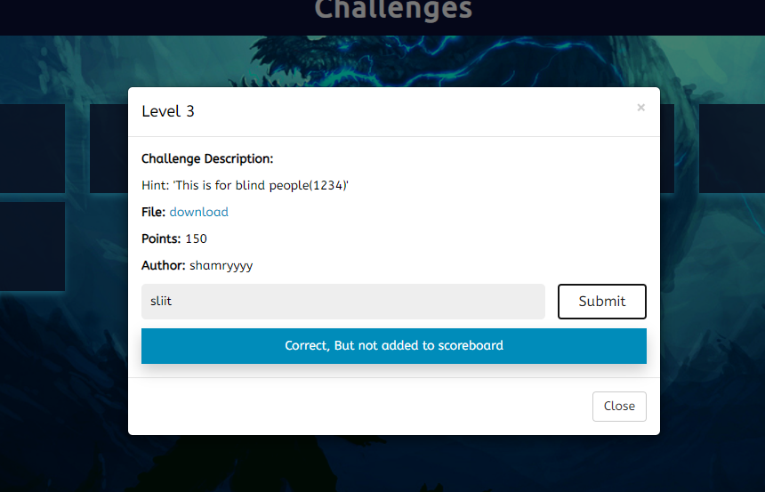Figure 4.7

**Level 5**

In this level we hid the flag in a text file.

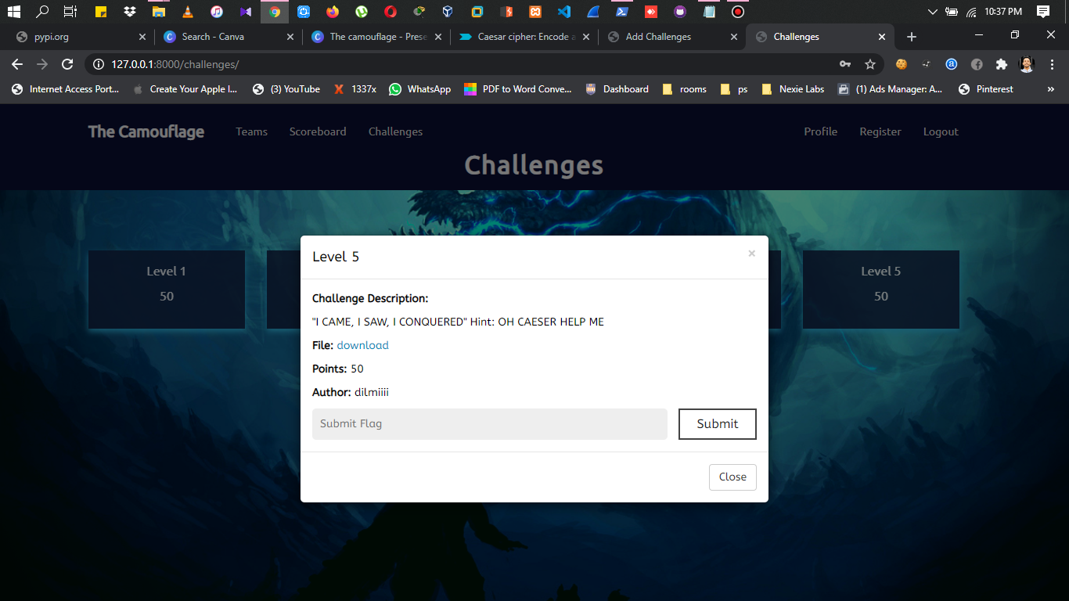

So download the file. And then search the flag inside the file.

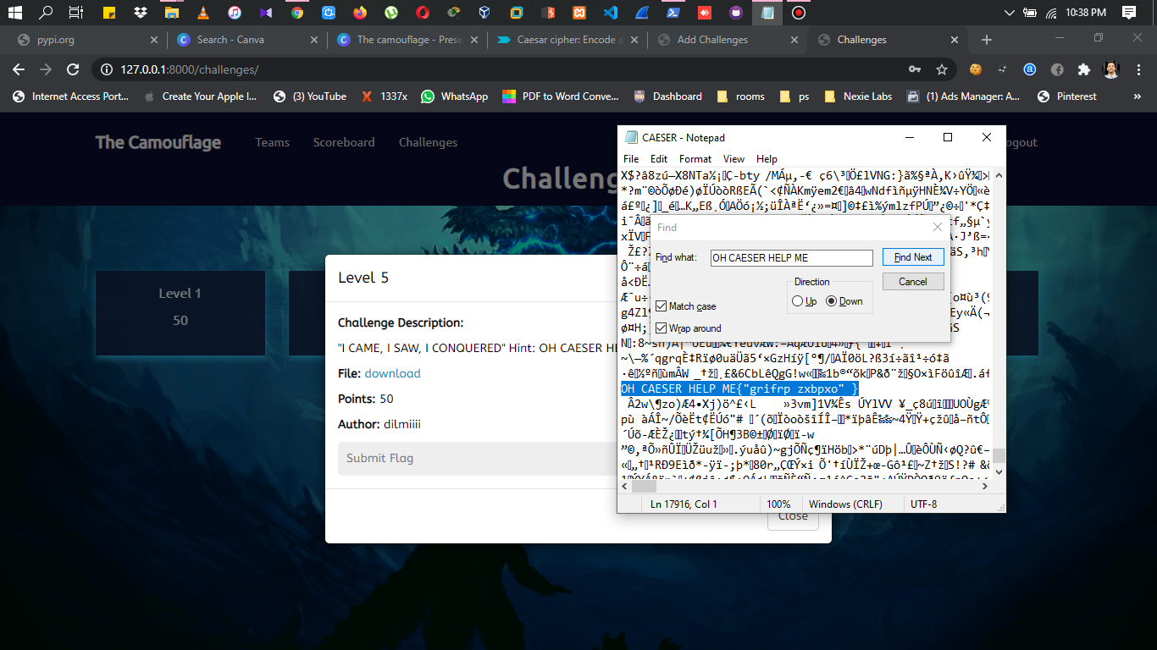

And then decode the flag using Caesar cipher online decoder.

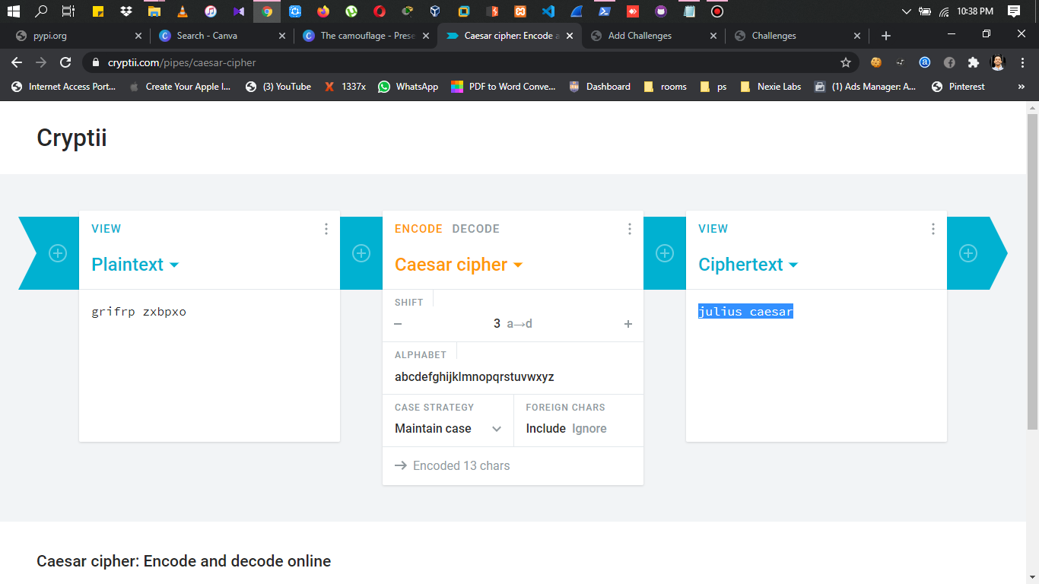

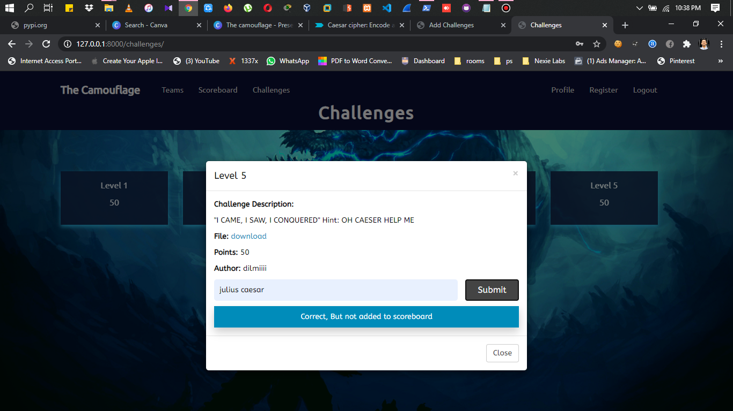Then submit the flag in the level 5.

YouTube video Link:

Gitub Report link: